|  |
| --- |
| LGE – CMU SW Architect course 2016 |
| Use Case Document |
| TEAM 2 – NOT YET |
|  |
| **Wonhong Kwon (wonhong.kwon@lge.com)** |
| **2016-06-21** |

|  |
| --- |
| This document describes use case diagram and scenarios for the studio project called Sure-Park System. |

Table of Contents

0. Document Revision 2

1. Terms 3

2. Use Case Diagram 3

3. Use Case Scenario 4

List of Use Cases 4

Use Case Scenarios 5

UCS-01: Verify credit card information 5

UCS-02: Sign up 5

UCS-03: Log in 6

UCS-04: Log out 7

UCS-05: Deactivate an account 7

UCS-06: Make reservation 8

UCS-07: Update user profile 8

UCS-08: Verify confirmation number on an entry gate 9

UCS-09: Pass through an entry gate 9

UCS-10: Park a car 10

UCS-11: Leave a facility 11

UCS-12: Check status of a facility 11

UCS-13: Check statistics of a facility 12

UCS-14: Configure the system 12

UCS-15: Manage slots and facilities 13

UCS-16: Add new analysis algorithm 13

3. References 14

0. Document Revision

|  |  |  |  |
| --- | --- | --- | --- |
| Version | Date | Description | Author |
| 0.1 | 2016.06.04 | Initial version | Wonhong Kwon |
| 0.2 | 2016.06.07 | Add “Terms” | Wonhong Kwon |
| 1.0 | 2016.06.21 | Version 1.0 | Wonhong Kwon |

1. Terms

* CCPS: Credit Card Payment System
* End-User: Person who uses Sure-Park System. End-User can be driver, attendant, operator, developer, or owner.
* Driver: Person who wants to reserve a parking spot.
* Operator: Person who administrates Sure-Park System.
* Developer: Person who develops/updates facility statistics analysis algorithm
* Owner: Person who owns parking facilities

2. Use Case Diagram

This use case diagram is based on the requirements described in [1] Project Description.

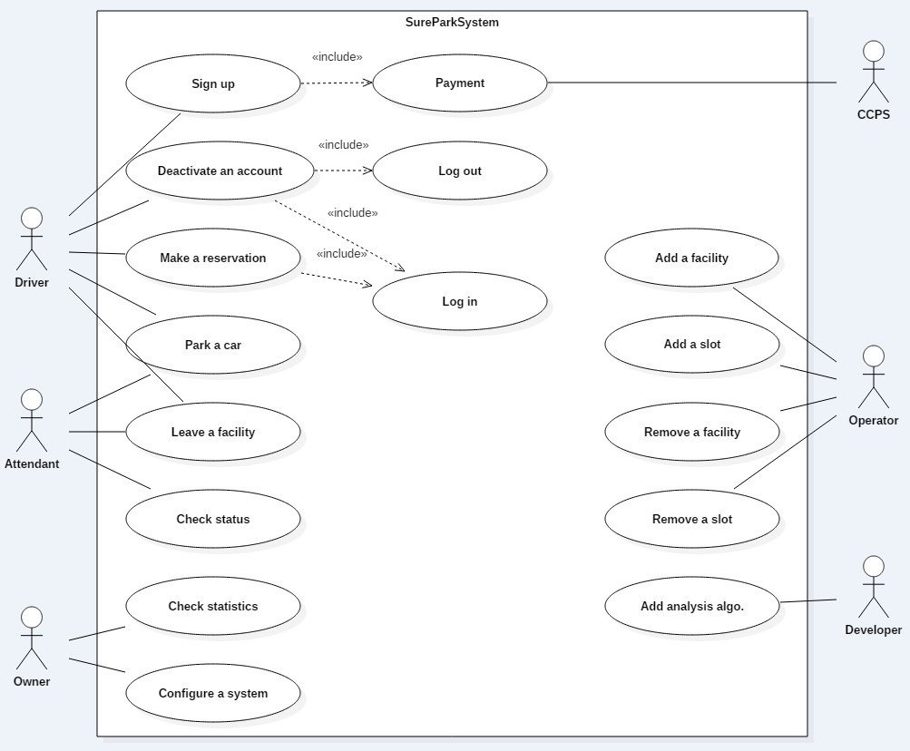

3. Use Case Scenario

These scenarios are derived from above “Use Case Diagram”.

## List of Use Cases

|  |  |
| --- | --- |
| ID | Description |
| UCS-01 | Verify credit card information |
| UCS-02 | Sign up |
| UCS-03 | Log in |
| UCS-04 | Log out |
| UCS-05 | Deactivate an account |
| UCS-06 | Make reservation |
| UCS-07 | Update user profile |
| UCS-08 | Verify confirmation number on an entry gate |
| UCS-09 | Pass through an entry gate |
| UCS-10 | Park a car |
| UCS-11 | Leave a facility |
| UCS-12 | Check status of a facility |
| UCS-13 | Check statistics of the system |
| UCS-14 | Configure the system |
| UCS-15 | Manage slots and facilities |
| UCS-16 | Add new analysis algorithm |

## Use Case Scenarios

### UCS-01: Verify credit card information

|  |
| --- |
| **Use Case Title**: Verify credit card information |
| **Use Case ID**: UCS-01 |
| **Version**: 0.1 |
| **Last Changed**: 2016.06.02 |
| **General Use Case Description**:  This scenario describes how Sure-Park System verifies Driver’s credit card information with CCAS |
| **Entities Involved**:  E01 – Driver  E02 – Sure-Park System  E03 – CCAS  E04 – Operator |
| **Pre-condition**:  E02 (Sure-Park System) must have E01 (Driver)’s credit card information to be verified.  E02 (Sure-Park System) must have a valid connection to E03 (CCAS). |
| **Primary Use Case Flow of Events**:   1. E02 (Sure-Park System) sends E01 (Driver)’s credit card information to E03 (CCAS). 2. E02 (Sure-Park System) receives a response from E03 (CCAS).   **Extensions:**  2a. E03 (CCAS) doesn’t response E02 (Sure-Park System)’s request for 30 seconds.  2a1. E02 (Sure-Park System) should notify this to both E01 (Driver) and E04 (Operator).  2b. E03 (CCAS) responses that E01 (Driver)’s credit card information is not valid.  2b1. E02 (Sure-Park System) should notify this to E01 (Driver) and requests to E01 that E01 should update credit card information. |
| **Primary Use Case Post-conditions:**  E02 (Sure-Park System) can think that E01 (Driver)’s credit card information is valid enough. |

### UCS-02: Sign up

|  |
| --- |
| **Use Case Title**: Sign up |
| **Use Case ID**: UCS-02 |
| **Version**: 0.1 |
| **Last Changed**: 2016.06.02 |
| **General Use Case Description**:  This scenario describes how Driver signs up to Sure-Park System. |
| **Entities Involved**:  E01 – Driver  E02 – Sure-Park System |
| **Pre-condition**:  E01 (Driver) is able to access E02 (Sure-Park System).  E01 (Driver) must have a credit card. (Our system doesn’t support other payment method.) |
| **Primary Use Case Flow of Events**:   1. E01 (Driver) accesses E02 (Sure-Park System) and selects “Sign up”. 2. E01 (Driver) inputs ID, password, credit card information. 3. E01 (Driver) selects OK. 4. E02 (Sure-Park System) verifies ID. 5. E02 (Sure-Park System) verifies password. 6. Include [UCS-01] to verify credit card information. 7. E02 (Sure-Park System) shows confirmation message to E01 (Driver)   **Extensions:**  3a. If E01 (Driver) doesn’t input ID, password, or credit card information, E02 (Sure-Park System) needs to notify E01 to input ID, password, or credit card information correctly.  4a. If E02 (Sure-Park System) detects duplicated ID; E02 needs to notify E01 (Driver) to use another ID.  5a. If E02 (Sure-Park System) detects invalid password format; E02 needs to notify E01 (Driver) to use another password format. |
| **Primary Use Case Post-conditions:**  E01 (Driver) can sign-up to E02 (Sure-Park System). |

### UCS-03: Log in

|  |
| --- |
| **Use Case Title**: Log in |
| **Use Case ID**: UCS-03 |
| **Version**: 0.1 |
| **Last Changed**: 2016.06.02 |
| **General Use Case Description**:  This scenario describes how End-User logs in to Sure-Park System. |
| **Entities Involved**:  E01 – End-User  E02 – Sure-Park System  E03 – Attendant |
| **Pre-condition**:  E01 (End-User) is able to access E02 (Sure-Park System).  E01 (End-User) should have an account. |
| **Primary Use Case Flow of Events**:   1. E01 (End-User) accesses E02 (Sure-Park System) and selects “Log in”. 2. E01 (End-User) inputs ID and password. 3. E01 (End-User) selects OK. 4. E02 (Sure-Park System) verifies E01 (End-User)’s ID and password. 5. E02 (Sure-Park System) checks E01 (End-User)’s authority and shows a first page based on E01’s authority.   **Extensions:**  3a. If E01 (End-User) doesn’t input ID and password correctly, E02 (Sure-Park System) should inform that to E01.  4a. If E01 (End-User)’s ID and password is invalid,  4a1. Step 4a occurs less than 5 times in 5 minutes, just go to Step 2.  4a2. Step 4a occurs 5 times in 5 minutes,  4a2a. E02 (Sure-Park System) notifies to E01 (End-User) that E01 cannot try to log in anymore for security and needs to ask to E03 (Attendant) to log in again. |
| **Primary Use Case Post-conditions:**  E01 (End-User) can log in to E02 (Sure-Park System) |

### UCS-04: Log out

|  |
| --- |
| **Use Case Title**: Log out |
| **Use Case ID**: UCS-04 |
| **Version**: 0.1 |
| **Last Changed**: 2016.06.02 |
| **General Use Case Description**:  This scenario describes how End-User logs out from Sure-Park System. |
| **Entities Involved**:  E01 – End-User  E02 – Sure-Park System |
| **Pre-condition**:  E01 (End-User) must have been logged in to E02 (Sure-Park System) already. |
| **Primary Use Case Flow of Events**:   1. E01 (End-User) accesses E02 (Sure-Park System) and selects “Log out”. 2. E01 (End-User) is logged out. 3. E02 (Sure-Park System) shows an initial page.   **Extensions:**  N/A |
| **Primary Use Case Post-conditions:**  E01 (End-User) can log out from E02 (Sure-Park System) |

### UCS-05: Deactivate an account

|  |
| --- |
| **Use Case Title**: Deactivate an account |
| **Use Case ID**: UCS-05 |
| **Version**: 0.1 |
| **Last Changed**: 2016.06.03 |
| **General Use Case Description**:  This scenario describes how Driver deactivates an account. |
| **Entities Involved**:  E01 – Driver  E02 – Sure-Park System |
| **Pre-condition**:  E01 (Driver) is able to access E02 (Sure-Park System).  E01 (Driver) should have an account. |
| **Primary Use Case Flow of Events**:   1. E01 (Driver) accesses E02 (Sure-Park System) and selects “Log in”. 2. Include [UCS-03] to log in to E02 (Sure-Park System) 3. E01 (Driver) selects “Deactivate an account”. 4. E02 (Sure-Park System) asks to E01 (Driver) that E01 really wants to deactivate an account. 5. E01 (Driver) confirms that he/she really wants to deactivate an account. 6. Include [UCS-04] to log out from E02 (Sure-Park System). 7. E02 (Sure-Park System) removes E01 (Driver) account. 8. E02 (Sure-Park System) notifies to E01 (Driver) that E01’s account has been deactivated.   **Extensions:**  7a. If E02 (Sure-Park System) cannot remove E01 (Driver)’s account, E02 should notify E01 that E01 needs to request this operation again. |
| **Primary Use Case Post-conditions:**  E01 (Driver) can deactivate an account and is logged out. |

### UCS-06: Make reservation

|  |
| --- |
| **Use Case Title**: Make reservation |
| **Use Case ID**: UCS-06 |
| **Version**: 0.1 |
| **Last Changed**: 2016.06.03 |
| **General Use Case Description**:  This scenario describes how Driver makes reservation to reserve a parking spot. |
| **Entities Involved**:  E01 – Driver  E02 – Sure-Park System |
| **Pre-condition**:  E01 (Driver) is able to access E02 (Sure-Park System).  E01 (Driver) should have his/her account. |
| **Primary Use Case Flow of Events**:   1. E01 (Driver) accesses E02 (Sure-Park System) and selects “Log in”. 2. Include [UCS-03] to log in to E02 (Sure-Park System) 3. E01 (Driver) selects “Reserve a parking spot” and E02 (Sure-Park System) shows a page for reserving a parking spot. 4. E02 (Sure-Park System) provides which date and time can be available and E01 (Driver) selects date and time when he/she wants to reserve. 5. E01 (Driver) updates credit card information if he/she wants to update it. 6. E01 (Driver) selects OK. 7. Include [UCS-01] to verify E01 (Driver)’s credit card information. 8. E02 (Sure-Park System) gives confirmation number to E01 (Driver).   **Extensions:**  N/A |
| **Primary Use Case Post-conditions:**  E01 (Driver) can reserve a parking spot on particular date and time and get confirmation number from E02 (Sure-Park System). |

### UCS-07: Update user profile

|  |
| --- |
| **Use Case Title**: Update user profile |
| **Use Case ID**: UCS-07 |
| **Version**: 0.1 |
| **Last Changed**: 2016.06.03 |
| **General Use Case Description**:  This scenario describes how Driver updates his/her profile. |
| **Entities Involved**:  E01 – Driver  E02 – Sure-Park System |
| **Pre-condition**:  E01 (Driver) is able to access E02 (Sure-Park System).  E01 (Driver) should have his/her account. |
| **Primary Use Case Flow of Events**:   1. E01 (Driver) accesses E02 (Sure-Park System) and selects “Log in”. 2. Include [UCS-03] to log in to E02 (Sure-Park System) 3. E01 (Driver) selects “Update user profile”. 4. E01 (Driver) can input new password or credit card information. 5. E01 (Driver) selects OK. 6. E02 (Sure-Park System) verifies password. 7. Include [UCS-01] to verify credit card information. 8. E02 (Sure-Park System) notifies to E01 (Driver) that his/her information has been changed successfully.   **Extensions:**  6a. If E02 (Sure-Park System) detects invalid password format; E02 needs to notify E01 (Driver) to use another password format. |
| **Primary Use Case Post-conditions:**  E01 (Driver)’s profile has been updated successfully. |

### UCS-08: Verify confirmation number on an entry gate

|  |
| --- |
| **Use Case Title**: Verify confirmation number on an entry gate |
| **Use Case ID**: UCS-08 |
| **Version**: 0.1 |
| **Last Changed**: 2016.06.03 |
| **General Use Case Description**:  When Driver arrives at an entry gate, Sure-Park System verifies the Driver based on confirmation number. |
| **Entities Involved**:  E01 – Driver  E02 – Sure-Park System  E03 – Attendant |
| **Pre-condition**:  E01 (Driver) has made reservation successfully and has confirmation number. |
| **Primary Use Case Flow of Events**:   1. E01 (Driver) provides confirmation number to E02 (Sure-Park System). 2. E02 (Sure-Park System) verifies E01 (Driver)’s reservation using confirmation number.   **Extensions:**  2a. If E01 (Driver)’s confirmation number is not valid, E02 (Sure-Park System) notifies that to both E01 and E03 (Attendant). |
| **Primary Use Case Post-conditions:**  E01 (Driver)’s reservation is verified successfully. |

### UCS-09: Pass through an entry gate

|  |
| --- |
| **Use Case Title**: Pass through an entry gate |
| **Use Case ID**: UCS-09 |
| **Version**: 0.1 |
| **Last Changed**: 2016.06.04 |
| **General Use Case Description**:  As Driver approaches an entry gate, Sure-Park System will detect the presence of a car at the gate. The gate LED will be red and the gate closed. Then, Sure-Park System verifies the driver. Once verified, the gate LED will turn green and open the gate allowing the driver to pass gate. |
| **Entities Involved**:  E01 – Driver  E02 – Sure-Park System  E03 – Attendant |
| **Pre-condition**:  E01 (Driver) has made reservation successfully and has confirmation number. |
| **Primary Use Case Flow of Events**:   1. E02 (Sure-Park System) detects the presence of a car at the gate. 2. Include [UCS-08] to verify E01 (Driver)’s confirmation number. 3. E02 (Sure-Park System) changes a gate LED to green and open the gate. 4. E01 (Driver) passes the gate and E02 (Sure-Park System) detects the absence of the car at the gate. 5. E02 (Sure-Park System) changes the gate LED to red and close the gate.   **Extensions:**  1a. If a grace-period is expired and E01 (Driver) doesn’t show up, E02 (Sure-Park System) invalidates E01’s reservation.  4a. If E02 (Sure-Park System) cannot detect the absence of the car at the gate in a minute after the gate is opened, E02 notifies this to E03 (Attendant) |
| **Primary Use Case Post-conditions:**  Gate is closed and color of gate LED is changed to red. |

### UCS-10: Park a car

|  |
| --- |
| **Use Case Title**: Park a car |
| **Use Case ID**: UCS-10 |
| **Version**: 0.1 |
| **Last Changed**: 2016.06.04 |
| **General Use Case Description**:  As a driver approaches the parking facility, the system will detect the presence of a car at the entry gate. The entry gate LED will be red and the gate closed. The driver will provide confirmation information to the system that will identify the driver. The system will verify the driver’s information and confirm their reservation. Once verified, the entry gate LED will turn green and raise the gate allowing the driver to enter the parking area. The system will assign a parking space by illuminating the green LED at the assigned parking space. Once the car is in position in the parking space, the green LED at the parking space will be turned off. |
| **Entities Involved**:  E01 – Driver  E02 – Sure-Park System  E03 – Attendant |
| **Pre-condition**:  E01 (Driver) has made reservation successfully and has confirmation number. |
| **Primary Use Case Flow of Events**:   1. Include [UCS-09] 2. E02 (Sure-Park System) selects an empty parking slot. 3. E02 (Sure-Park System) blinks the green LED at the assigned slot. 4. E01 (Driver) parks a car in the slot and E02 (Sure-Park System) detects the car parked. 5. E02 (Sure-Park System) turns off the LED.   **Extensions:**  2a. If there is no parking slot available, E02 (Sure-Park System) notifies this to E03 (Attendant).  4a. If E01 (Driver) parks a car in a wrong slot, E02 (Sure-Park System) re-assigns parking slots and notifies this to E03 (Attendant).  4b. If E02 (Sure-Park System) detects that a car is not parked anywhere in 3 minutes after a gate is closed, E02 notifies this to E03 (Attendant) |
| **Primary Use Case Post-conditions:**  E02 (Sure-Park System) update the status of the parking spaces.  E02 updates E01 (Driver)’s reservation status.  E02 stops counting a grace-period of E01’s reservation.  E02 starts to count how long E01 stays in a parking facility.  All LED-s in the parking spots are turned off. |

### UCS-11: Leave a facility

|  |
| --- |
| **Use Case Title**: Leave a facility |
| **Use Case ID**: UCS-11 |
| **Version**: 0.1 |
| **Last Changed**: 2016.06.04 |
| **General Use Case Description**:  A driver leaves the parking space and drive toward the exit gate. The exit gate LED will be red. Once the system detects the car at the gate, the system will raise the gate and turn the exit gate LED green. Drivers are charged by the hour for parking after they enter the garage (time of entry, to time of departure from the parking slot). Customers will automatically be charged on their credit card for the duration of their stay. |
| **Entities Involved**:  E01 – Driver  E02 – Sure-Park System  E03 – Attendant |
| **Pre-condition**:  TBD |
| **Primary Use Case Flow of Events**:   1. TBD   **Extensions:**  TBD |
| **Primary Use Case Post-conditions:**  TBD |

### UCS-12: Check status of a facility

|  |
| --- |
| **Use Case Title**: Check status of a facility |
| **Use Case ID**: UCS-12 |
| **Version**: 0.1 |
| **Last Changed**: 2016.06.04 |
| **General Use Case Description**:  Attendant wants to check status of a facility |
| **Entities Involved**:  E01 – Attendant  E02 – Sure-Park System |
| **Pre-condition**:  E01 (Attendant) has an account. |
| **Primary Use Case Flow of Events**:   1. Include [UCS-03] to log in to E02 (Sure-Park System) 2. E02 (Sure-Park System) shows following status to E01 (Attendant).    1. Which parking spots are open and which are occupied.    2. How long a car has occupied a particular parking spot    3. When a driver parks in the wrong parking space and will automatically reassign parking spaces and correlate associated reservations.   **Extensions:**  N/A |
| **Primary Use Case Post-conditions:**  E01 (Attendant) can see the status of a facility. |

### UCS-13: Check statistics of a facility

|  |
| --- |
| **Use Case Title**: Check statistics of a facility |
| **Use Case ID**: UCS-13 |
| **Version**: 0.1 |
| **Last Changed**: 2016.06.04 |
| **General Use Case Description**:  Owner wants to check statistics of a facility. |
| **Entities Involved**:  E01 – Owner  E02 – Sure-Park System |
| **Pre-condition**:  E01 (Owner) has an account. |
| **Primary Use Case Flow of Events**:   1. Include [UCS-03] to log in to E02 (Sure-Park System) 2. E02 (Sure-Park System) shows following facility statistics to E01 (Owner).    1. Average occupancy    2. Peak usage hours    3. Parking slot statistics (how much time cars were parked in parking slots)    4. Revenue   **Extensions:**  N/A |
| **Primary Use Case Post-conditions:**  E01 (Owner) can see the statistics of the facility. |

### UCS-14: Configure the system

|  |
| --- |
| **Use Case Title**: Configure the system |
| **Use Case ID**: UCS-14 |
| **Version**: 0.1 |
| **Last Changed**: 2016.06.04 |
| **General Use Case Description**:  Owner wants to configure the system. |
| **Entities Involved**:  E01 – Owner  E02 – Sure-Park System |
| **Pre-condition**:  E01 (Owner) has an account. |
| **Primary Use Case Flow of Events**:   1. Include [UCS-03] to log in to E02 (Sure-Park System) 2. E01 (Owner) selects “Configure the system” page. 3. E02 (Sure-Park System) shows a configuration list to E01 (Owner). 4. E01 (Owner) changes some configurations and select OK. 5. E02 (Sure-Park System) configures the system with updated values.   **Extensions:**  4a. If E01 (Owner)’s change is not valid, E02 (Sure-Park System) notifies this to E01. |
| **Primary Use Case Post-conditions:**  E01 (Owner) applies new configurations to E02 (Sure-Park System). |

### UCS-15: Manage slots and facilities

|  |
| --- |
| **Use Case Title**: Manage slots and facilities |
| **Use Case ID**: UCS-15 |
| **Version**: 0.1 |
| **Last Changed**: 2016.06.04 |
| **General Use Case Description**:  Owner wants to configure the system. |
| **Entities Involved**:  E01 – Owner  E02 – Sure-Park System |
| **Pre-condition**:  E01 (Owner) has an account. |
| **Primary Use Case Flow of Events**:   1. Include [UCS-03] to log in to E02 (Sure-Park System) 2. E01 (Owner) selects “Configure the system” page. 3. E02 (Sure-Park System) shows a configuration list to E01 (Owner). 4. E01 (Owner) changes some configurations and select OK. 5. E02 (Sure-Park System) configures the system with updated values.   **Extensions:**  4a. If E01 (Owner)’s change is not valid, E02 (Sure-Park System) notifies this to E01. |
| **Primary Use Case Post-conditions:**  E01 (Owner) applies new configurations to E02 (Sure-Park System). |

### UCS-16: Add new analysis algorithm

|  |
| --- |
| **Use Case Title**: Add new analysis algorithm |
| **Use Case ID**: UCS-16 |
| **Version**: 0.1 |
| **Last Changed**: 2016.06.04 |
| **General Use Case Description**:  The system should be extensible to enable developers to add more analysis algorithms or analysis applications without disrupting operations to add the new features. |
| **Entities Involved**:  E01 – Developer  E02 – Sure-Park System |
| **Pre-condition**:  E01 (Developer) has an account.  E01 (Developer) has new analysis algorithm to be added. |
| **Primary Use Case Flow of Events**:   1. Include [UCS-03] to log in to E02 (Sure-Park System) 2. TBD: How does E01 (Developer) add his/her new analysis algorithm? 3. TBD: How does E01 (Developer) confirm that his/her new algorithm is added to E02 (Sure-Park System) successfully?   **Extensions:**  TBD: Exceptional cases should be handled. |
| **Primary Use Case Post-conditions:**  E01 (Developer) applies new analysis algorithm to E02 (Sure-Park System) |

3. References

[1] Sure-Park: Parking Garage Management System Project Description – V2